Case 6-Afr-Nigeria-Igbo-Door-Large
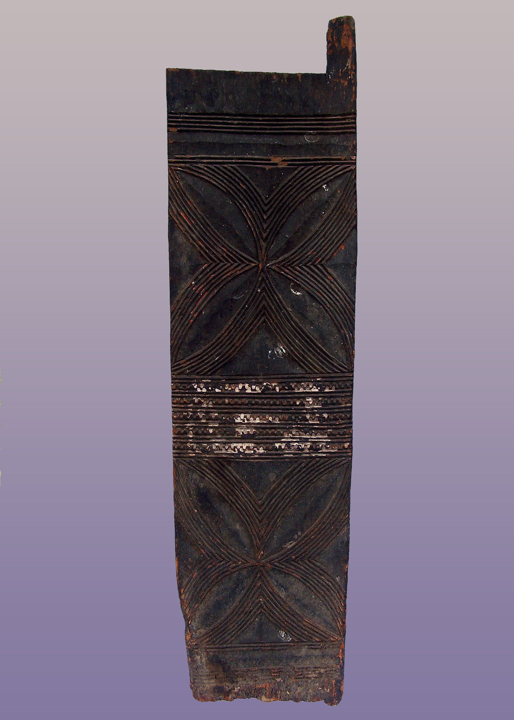

Large Igbo Door from Nigeria 65"h x 17"w x 1"d
Price:
US $1,495.00

